Jerry Banfield FB Advertising Sidenote 1:

Jerry Banfield


posted an announcement · 3 days ago
You get 8 new Facebook ads tutorial videos today in section 4 of your complete Facebook ads course on Udemy showing the basics of the newest interface and what works best for me today in Facebook ads! All of these lectures were filmed today and show what is working best for me today using live campaigns plus data from previous campaigns for comparison.
Page post engagement objective campaigns using page posts with videos uploaded to my page are working to get me the most enthusiastic audience on my page for the lowest cost AND to get the most conversions at the lowest price. On average this is working 10 times more effectively than anything I have done before in the USA, Canada, UK, and Australia. You get a full introduction to this strategy in the new section 4 videos and can see the results below along with a description of the strategy.
These are the results from the last 30 days of my newest xbox videos campaign along with an explanation of why I run the ads like this.
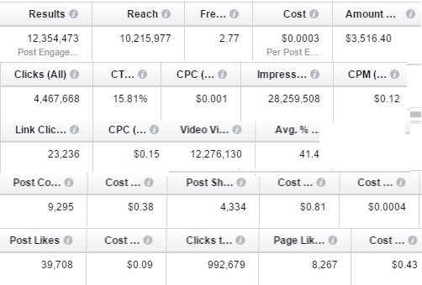
This is the top performing ad out of this campaign.
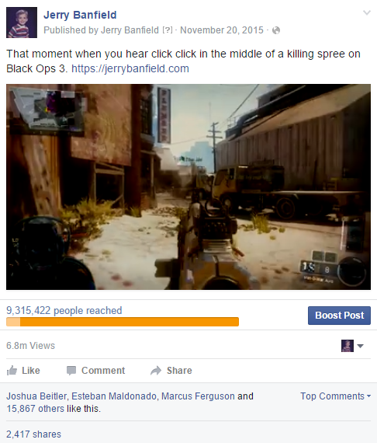
The purpose of doing the ads like what you see above is to provide the same type of videos that I normally watch as a user on Facebook. The video then gets out to a huge audience for a low cost instead of a very small audience at a high cost. A small percentage of the large audience is likely to be my ideal audience just because my ideal audience includes people just like me.
What most people see is an entertaining video worth watching and maybe sharing. For a few people see is proof of exactly what I am teaching presented in a "see the results for yourself" format. When they use the link in the ad they then have a choice to get to know what I am doing for free and then buy a course if they choose.
The setup above is designed to maximize guaranteed wins and can be adapted to anything you are doing. You can make videos about your favorite hobbies and tie them back into what you are selling. Even if you just want to use a sales video instead of an entertaining video, you can still get exceptional results using the same strategy above.
In the new section 4 lectures, I show this and some tips for how to work in the Facebook ads interface with minimal frustration. Facebook also has a new live chat feature you might enjoy for support athttps://www.facebook.com/business/resources/.
Thank you very much for reading this! I value your feedback on these new lectures because then I can know what changes to make to the course in the future to continue improving it!
Sincerely,
Jerry Banfield
Who are you perfectly qualified to help? My newest daily inspirational podcast episode at https://itunes.apple.com/podcast/id915442105

