[Collapse]
Wikipedia is a non-profit project: please donate today.
$3,542,330
Our Goal: $6 million
Donate Now »
[Expand]
Support Wikipedia: a non-profit project.
Donate Now »

Program Evaluation and Review Technique

From Wikipedia, the free encyclopedia
Jump to: navigation, search
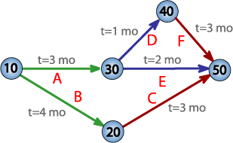
PERT network chart for a seven-month project with five milestones (10 through 50) and six activities (A through F).
The Program (or Project) Evaluation and Review Technique, commonly abbreviated PERT, is a model for project management designed to analyze and represent the tasks involved in completing a given project.

Contents
[hide]
- 1 Overview
- 2 PERT terminology and conventions
  - 2.1 Conventions
  - 2.2 Terminology
- 3 Implementing PERT
- 4 See also
- 5 References
- 6 Further reading
- 7 External links

[edit] Overview
PERT is a method to analyze the involved tasks in completing a given project, especially the time needed to complete each task, and identifying the minimum time needed to complete the total project.
This model was invented by Booz Allen Hamilton, Inc. under contract to the United States Department of Defense's US Navy Special Projects Office in 1958 as part of the Polaris mobile submarine-launched ballistic missile project. This project was a direct response to the Sputnik crisis. Some US government contracts required that PERT be used as part of management supervision.
PERT was developed primarily to simplify the planning and scheduling of large and complex projects. It was able to incorporate uncertainty by making it possible to schedule a project while not knowing precisely the details and durations of all the activities. It is more of an event-oriented technique rather than start- and completion-oriented, and is used more in R&D-type projects where time, rather than cost, is the major factor.
This project model was the first of its kind, a revival for scientific management, founded in Fordism and Taylorism. Only DuPont corporation's critical path method was invented at roughly the same time as PERT.
The most recognizable feature of PERT is the "PERT Networks", a chart of interconnecting timelines. PERT is intended for very large-scale, one-time, complex, non-routine projects.

[edit] PERT terminology and conventions

[edit] Conventions
- A PERT chart is a tool that facilitates decision making; The first draft of a PERT chart will number its events sequentially in 10s (10, 20, 30, etc.) to allow the later insertion of additional events.
- Two consecutive events in a PERT chart are linked by activities, which are conventionally represented as arrows in the diagram above.
- The events are presented in a logical sequence and no activity can commence until its immediately preceding event is completed.
- The planner decides which milestones should be PERT events and also decides their “proper” sequence.
- A PERT chart may have multiple pages with many sub-tasks.

[edit] Terminology
- A PERT event: is a point that marks the start or completion of one or more tasks. It consumes no time, and uses no resources. It marks the completion of one or more tasks, and is not “reached” until all of the activities leading to that event have been completed.
- A predecessor event: an event (or events) that immediately precedes some other event without any other events intervening. It may be the consequence of more than one activity.
- A successor event: an event (or events) that immediately follows some other event without any other events intervening. It may be the consequence of more than one activity.
- A PERT activity: is the actual performance of a task. It consumes time, it requires resources (such as labour, materials, space, machinery), and it can be understood as representing the time, effort, and resources required to move from one event to another. A PERT activity cannot be completed until the event preceding it has occurred.
- Optimistic time (O): the minimum possible time required to accomplish a task, assuming everything proceeds better than is normally expected
- Pessimistic time (P): the maximum possible time required to accomplish a task, assuming everything goes wrong (but excluding major catastrophes).
- Most likely time (M): the best estimate of the time required to accomplish a task, assuming everything proceeds as normal.
- Expected time (T_{E}): the best estimate of the time required to accomplish a task, assuming everything proceeds as normal (the implication being that the expected time is the average time the task would require if the task were repeated on a number of occasions over an extended period of time).
T_{E} = (O + 4M + P) ÷ 6
- Critical Path: the longest possible continuous pathway taken from the initial event to the terminal event. It determines the total calendar time required for the project; and, therefore, any time delays along the critical path will delay the reaching of the terminal event by at least the same amount.
- Critical Activity: An activity that has total float equal to zero. Activity with zero float does not mean it is on critical path.
- Lead time (rhymes with "feed", not "fed"): the time by which a predecessor event must be completed in order to allow sufficient time for the activities that must elapse before a specific PERT event is reached to be completed.
- Lag time: the earliest time by which a successor event can follow a specific PERT event.
- Slack: the slack of an event is a measure of the excess time and resources available in achieving this event. Positive slack(+) would indicate ahead of schedule; negative slack would indicate behind schedule; and zero slack would indicate on schedule.
- Fast tracking: performing more critical activities in parallel
- Crashing critical path: Shortening duration of critical activities
- Float or Slack is the amount of time that a task in a project network can be delayed without causing a delay - Subsequent tasks – (free float) or Project Completion – (total float)

[edit] Implementing PERT
The first step to scheduling the project is to determine the tasks that the project requires and the order in which they must be completed. The order may be easy to record for some tasks (e.g. When building a house, the land must be graded before the foundation can be laid) while difficult for others (There are two areas that need to be graded, but there are only enough bulldozers to do one). Additionally, the time estimates usually reflect the normal, non-rushed time. Many times, the time required to execute the task can be reduced for an additional cost or a reduction in the quality.
In the following example there are seven tasks, labeled a through g. Some tasks can be done concurrently (a & b) while others cannot be done until their predecessor task is complete (c cannot begin until a is complete). Additionally, each task has three time estimates: the optimistic time estimate (a), the most likely or normal time estimate (m), and the pessimistic time estimate (b). The expected time (T_{E}) is computed using the formula (a + 4m + b) /6.
Activity | Predecessor | Opt.  a | Norm.  m | Pess.  b | T_{E}  (a + 4m + b) /6
a | -- | 2 | 4 | 6 | 4.00
b | -- | 3 | 5 | 9 | 5.33
c | a | 4 | 5 | 7 | 5.17
d | a | 4 | 6 | 10 | 6.33
e | b, c | 4 | 5 | 7 | 5.17
f | d | 3 | 4 | 8 | 4.50
g | e | 3 | 5 | 8 | 5.17
Note: All times listed are in work days (Mon - Fri, 8 A.M. to 5 P.M. with a one hour lunch break).
Once this step is complete, one can draw a Gantt chart or a network diagram.
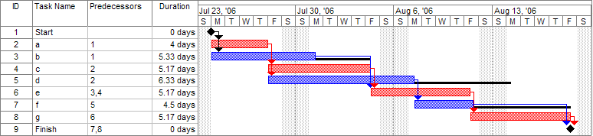
A Gantt chart created using Microsoft Project (MSP). Note (1) the critical path is in red, (2) the slack is the black lines connected to non-critical activities, (3) when using MSP, you must use the task ID when labeling predecessor activities, and (4) since Saturday and Sunday are not work days (as described above) some bars on the Gantt chart are longer if they cut through a weekend.

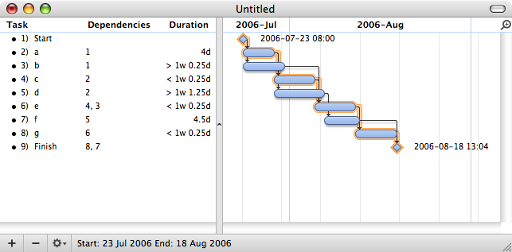
A Gantt chart created using OmniPlan. Note (1) the critical path is highlighted, (2) the slack is not specifically indicated on task 5 (d), though it can be observed on tasks 3 and 7 (b and f), (3) when using OmniPlan, you may use the GUI to easily link dependencies, or you may enter them by reference to task ID, and (4) since weekends are indicated by a thin vertical line, and take up no additional space on the work calendar, bars on the Gantt chart are not longer or shorter when they do or don't carry over a weekend.
A network diagram can be created by hand or by using diagram software. There are two types of network diagrams, activity on arrow (AOA) and activity on node (AON). Activity on node diagrams are generally easier to create and interpret. To create an AON diagram, it is recommended (but not required) to start with a node named start. This "activity" has a duration of zero (0). Then you draw each activity that does not have a predecessor activity (a and b in this example) and connect them with an arrow from start to each node. Next, since both c and d list a as a predecessor activity, their nodes are drawn with arrows coming from a. Activity e is listed with b and c as predecessor activities, so node e is drawn with arrows coming from both b and c, signifying that e cannot begin until both b and c have been completed. Activity f has d as a predecessor activity, so an arrow is drawn connecting the activities. Likewise, an arrow is drawn from e to g. Since there are no activities that come after f or g, it is recommended (but again not required) to connect them to a node labeled finish.
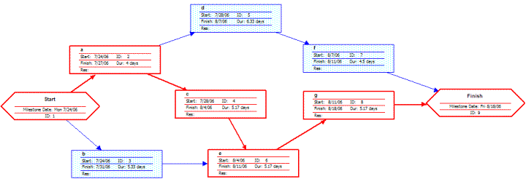
A network diagram created using Microsoft Project (MSP). Note the critical path is in red.
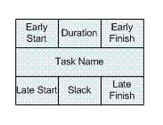
A node like this one (from Microsoft Visio) can be used to display the activity name, duration, ES, EF, LS, LF, and slack.
By itself, the network diagram pictured above does not give much more information than a Gantt chart; however, it can be expanded to display more information. The most common information shown is:
- The activity name
- The normal duration time
- The early start time (ES)
- The early finish time (EF)
- The late start time (LS)
- The late finish time (LF)
- The slack
In order to determine this information it is assumed that the activities and normal duration times are given. The first step is to determine the ES and EF. The ES is defined as the maximum EF of all predecessor activities, unless the activity in question is the first activity, for which the ES is zero (0). The EF is the ES plus the task duration (EF = ES + duration).
- The ES for start is zero since it is the first activity. Since the duration is zero, the EF is also zero. This EF is used as the ES for a and b.
- The ES for a is zero. The duration (4 work days) is added to the ES to get an EF of four. This EF is used as the ES for c and d.
- The ES for b is zero. The duration (5.33 work days) is added to the ES to get an EF of 5.33.
- The ES for c is four. The duration (5.17 work days) is added to the ES to get an EF of 9.17.
- The ES for d is four. The duration (6.33 work days) is added to the ES to get an EF of 10.33. This EF is used as the ES for f.
- The ES for e is the greatest EF of its predecessor activities (b and c). Since b has an EF of 5.33 and c has an EF of 9.17, the ES of e is 9.17. The duration (5.17 work days) is added to the ES to get an EF of 14.34. This EF is used as the ES for g.
- The ES for f is 10.33. The duration (4.5 work days) is added to the ES to get an EF of 14.83.
- The ES for g is 14.34. The duration (5.17 work days) is added to the ES to get an EF of 19.51.
- The ES for finish is the greatest EF of its predecessor activities (f and g). Since f has an EF of 14.83 and g has an EF of 19.51, the ES of finish is 19.51. Finish is a milestone (and therefore has a duration of zero), so the EF is also 19.51.
Barring any unforeseen events, the project should take 19.51 work days to complete. The next step is to determine the late start (LS) and late finish (LF) of each activity. This will eventually show if there are activities that have slack. The LF is defined as the minimum LS of all successor activities, unless the activity is the last activity, for which the LF equals the EF. The LS is the LF minus the task duration (LS = LF - duration).
- The LF for finish is equal to the EF (19.51 work days) since it is the last activity in the project. Since the duration is zero, the LS is also 19.51 work days. This will be used as the LF for f and g.
- The LF for g is 19.51 work days. The duration (5.17 work days) is subtracted from the LF to get an LS of 14.34 work days. This will be used as the LF for e.
- The LF for f is 19.51 work days. The duration (4.5 work days) is subtracted from the LF to get an LS of 15.01 work days. This will be used as the LF for d.
- The LF for e is 14.34 work days. The duration (5.17 work days) is subtracted from the LF to get an LS of 9.17 work days. This will be used as the LF for b and c.
- The LF for d is 15.01 work days. The duration (6.33 work days) is subtracted from the LF to get an LS of 8.68 work days.
- The LF for c is 9.17 work days. The duration (5.17 work days) is subtracted from the LF to get an LS of 4 work days.
- The LF for b is 9.17 work days. The duration (5.33 work days) is subtracted from the LF to get an LS of 3.84 work days.
- The LF for a is the minimum LS of its successor activities. Since c has an LS of 4 work days and d has an LS of 8.68 work days, the LF for a is 4 work days. The duration (4 work days) is subtracted from the LF to get an LS of 0 work days.
- The LF for start is the minimum LS of its successor activities. Since a has an LS of 0 work days and b has an LS of 3.84 work days, the LS is 0 work days.
The next step is to determine the critical path and if any activities have slack. The critical path is the path that takes the longest to complete. To determine the path times, add the task durations for all available paths. Activities that have slack can be delayed without changing the overall time of the project. Slack is computed in one of two ways, slack = LF - EF or slack = LS - ES. Activities that are on the critical path have a slack of zero (0).
- The duration of path adf is 14.83 work days.
- The duration of path aceg is 19.51 work days.
- The duration of path beg is 15.67 work days.
The critical path is aceg and the critical time is 19.51 work days. It is important to note that there can be more than one critical path (in a project more complex than this example) or that the critical path can change. For example, let's say that activities d and f take their pessimistic (b) times to complete instead of their expected (T_{E}) times. The critical path is now adf and the critical time is 22 work days. On the other hand, if activity c can be crashed to one work day, the path time for aceg is reduced to 15.34 work days, which is slightly less than the time of the new critical path, beg (15.67 work days).
Assuming these scenarios do not happen, the slack for each activity can now be determined.
- Start and finish are milestones and by definition have no duration, therefore they can have no slack (0 work days).
- The activities on the critical path by definition have a slack of zero; however, it is always a good idea to check the math anyway when drawing by hand.
  - LF_{a} - EF_{a} = 4 - 4 = 0
  - LF_{c} - EF_{c} = 9.17 - 9.17 = 0
  - LF_{e} - EF_{e} = 14.34 - 14.34 = 0
  - LF_{g} - EF_{g} = 19.51 - 19.51 = 0
- Activity b has an LF of 9.17 and an EF of 5.33, so the slack is 3.84 work days.
- Activity d has an LF of 15.01 and an EF of 10.33, so the slack is 4.68 work days.
- Activity f has an LF of 19.51 and an EF of 14.83, so the slack is 4.68 work days.
Therefore, activity b can be delayed almost 4 work days without delaying the project. Likewise, activity d or activity f can be delayed 4.68 work days without delaying the project (alternatively, d and f can be delayed 2.34 work days each).
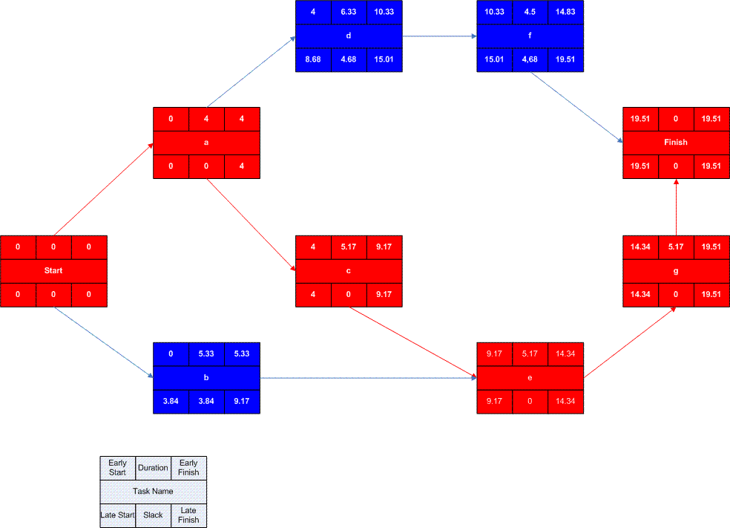
A completed network diagram created using Microsoft Visio. Note the critical path is in red.

[edit] See also
- Activity diagram
- Beta distribution
- Float (project management)
- Gantt chart
- Project network
- Project management
- Project planning
- Triangular distribution
- PRINCE2

[edit] References
 | This article does not cite any references or sources.  Please help improve this article by adding citations to reliable sources. Unverifiable material may be challenged and removed. (September 2008)

[edit] Further reading
- Project Management Institute (2003). A Guide To The Project Management Body Of Knowledge (3rd ed. ed.), Project Management Institute. ISBN 1-930699-45-X.
- Klastorin, Ted (2003). Project Management: Tools and Trade-offs (3rd ed. ed.), Wiley. ISBN 978-0471413844.
- Kerzner, Harold (2003). Project Management: A Systems Approach to Planning, Scheduling, and Controlling (8th Ed. ed.), Wiley. ISBN 0-471-22577-0.
- Milosevic, Dragan Z. (2003). Project Management ToolBox: Tools and Techniques for the Practicing Project Manager, Wiley. ISBN 978-0471208228.
- Lev Virine & Michael Trumper (2007). Project Decisions: The Art and Science, Management Concepts. ISBN 978-1567262179.

[edit] External links
 | Wikimedia Commons has media related to: PERT charts
- More explanation of PERT
- 3 Point Estimating Tutorial on VisionaryTools.com
Retrieved from "http://en.wikipedia.org/wiki/Program_Evaluation_and_Review_Technique"
Categories: Network theory | Diagrams | Evaluation | Project management | Production and manufacturing | Systems engineering
Hidden categories: Articles lacking sources from September 2008 | All articles lacking sources

Views
- Article
- Discussion
- Edit this page
- History

Personal tools
- Log in / create account

Navigation
- Main page
- Contents
- Featured content
- Current events
- Random article

Search

Interaction
- About Wikipedia
- Community portal
- Recent changes
- Contact Wikipedia
- Donate to Wikipedia
- Help

Toolbox
- What links here
- Related changes
- Upload file
- Special pages
- Printable version
- Permanent link
- Cite this page

Languages
- Български
- Deutsch
- Español
- Français
- 한국어
- Italiano
- Nederlands
- 日本語
- Polski
- Português
- Русский
- Svenska
- This page was last modified on 8 December 2008, at 05:47.
- All text is available under the terms of the GNU Free Documentation License. (See Copyrights for details.)
Wikipedia® is a registered trademark of the Wikimedia Foundation, Inc., a U.S. registered 501(c)(3) tax-deductible nonprofit charity.
- Privacy policy
- About Wikipedia
- Disclaimers
[Collapse]
Wikipedia is a non-profit project: please donate today.
$3,542,330
Our Goal: $6 million
Donate Now »
[Expand]
Support Wikipedia: a non-profit project.
Donate Now »

Program Evaluation and Review Technique

From Wikipedia, the free encyclopedia
Jump to: navigation, search
PERT network chart for a seven-month project with five milestones (10 through 50) and six activities (A through F).
The Program (or Project) Evaluation and Review Technique, commonly abbreviated PERT, is a model for project management designed to analyze and represent the tasks involved in completing a given project.

Contents
[hide]
- 1 Overview
- 2 PERT terminology and conventions
  - 2.1 Conventions
  - 2.2 Terminology
- 3 Implementing PERT
- 4 See also
- 5 References
- 6 Further reading
- 7 External links

[edit] Overview
PERT is a method to analyze the involved tasks in completing a given project, especially the time needed to complete each task, and identifying the minimum time needed to complete the total project.
This model was invented by Booz Allen Hamilton, Inc. under contract to the United States Department of Defense's US Navy Special Projects Office in 1958 as part of the Polaris mobile submarine-launched ballistic missile project. This project was a direct response to the Sputnik crisis. Some US government contracts required that PERT be used as part of management supervision.
PERT was developed primarily to simplify the planning and scheduling of large and complex projects. It was able to incorporate uncertainty by making it possible to schedule a project while not knowing precisely the details and durations of all the activities. It is more of an event-oriented technique rather than start- and completion-oriented, and is used more in R&D-type projects where time, rather than cost, is the major factor.
This project model was the first of its kind, a revival for scientific management, founded in Fordism and Taylorism. Only DuPont corporation's critical path method was invented at roughly the same time as PERT.
The most recognizable feature of PERT is the "PERT Networks", a chart of interconnecting timelines. PERT is intended for very large-scale, one-time, complex, non-routine projects.

[edit] PERT terminology and conventions

[edit] Conventions
- A PERT chart is a tool that facilitates decision making; The first draft of a PERT chart will number its events sequentially in 10s (10, 20, 30, etc.) to allow the later insertion of additional events.
- Two consecutive events in a PERT chart are linked by activities, which are conventionally represented as arrows in the diagram above.
- The events are presented in a logical sequence and no activity can commence until its immediately preceding event is completed.
- The planner decides which milestones should be PERT events and also decides their “proper” sequence.
- A PERT chart may have multiple pages with many sub-tasks.

[edit] Terminology
- A PERT event: is a point that marks the start or completion of one or more tasks. It consumes no time, and uses no resources. It marks the completion of one or more tasks, and is not “reached” until all of the activities leading to that event have been completed.
- A predecessor event: an event (or events) that immediately precedes some other event without any other events intervening. It may be the consequence of more than one activity.
- A successor event: an event (or events) that immediately follows some other event without any other events intervening. It may be the consequence of more than one activity.
- A PERT activity: is the actual performance of a task. It consumes time, it requires resources (such as labour, materials, space, machinery), and it can be understood as representing the time, effort, and resources required to move from one event to another. A PERT activity cannot be completed until the event preceding it has occurred.
- Optimistic time (O): the minimum possible time required to accomplish a task, assuming everything proceeds better than is normally expected
- Pessimistic time (P): the maximum possible time required to accomplish a task, assuming everything goes wrong (but excluding major catastrophes).
- Most likely time (M): the best estimate of the time required to accomplish a task, assuming everything proceeds as normal.
- Expected time (T_{E}): the best estimate of the time required to accomplish a task, assuming everything proceeds as normal (the implication being that the expected time is the average time the task would require if the task were repeated on a number of occasions over an extended period of time).
T_{E} = (O + 4M + P) ÷ 6
- Critical Path: the longest possible continuous pathway taken from the initial event to the terminal event. It determines the total calendar time required for the project; and, therefore, any time delays along the critical path will delay the reaching of the terminal event by at least the same amount.
- Critical Activity: An activity that has total float equal to zero. Activity with zero float does not mean it is on critical path.
- Lead time (rhymes with "feed", not "fed"): the time by which a predecessor event must be completed in order to allow sufficient time for the activities that must elapse before a specific PERT event is reached to be completed.
- Lag time: the earliest time by which a successor event can follow a specific PERT event.
- Slack: the slack of an event is a measure of the excess time and resources available in achieving this event. Positive slack(+) would indicate ahead of schedule; negative slack would indicate behind schedule; and zero slack would indicate on schedule.
- Fast tracking: performing more critical activities in parallel
- Crashing critical path: Shortening duration of critical activities
- Float or Slack is the amount of time that a task in a project network can be delayed without causing a delay - Subsequent tasks – (free float) or Project Completion – (total float)

[edit] Implementing PERT
The first step to scheduling the project is to determine the tasks that the project requires and the order in which they must be completed. The order may be easy to record for some tasks (e.g. When building a house, the land must be graded before the foundation can be laid) while difficult for others (There are two areas that need to be graded, but there are only enough bulldozers to do one). Additionally, the time estimates usually reflect the normal, non-rushed time. Many times, the time required to execute the task can be reduced for an additional cost or a reduction in the quality.
In the following example there are seven tasks, labeled a through g. Some tasks can be done concurrently (a & b) while others cannot be done until their predecessor task is complete (c cannot begin until a is complete). Additionally, each task has three time estimates: the optimistic time estimate (a), the most likely or normal time estimate (m), and the pessimistic time estimate (b). The expected time (T_{E}) is computed using the formula (a + 4m + b) /6.
Activity | Predecessor | Opt.  a | Norm.  m | Pess.  b | T_{E}  (a + 4m + b) /6
a | -- | 2 | 4 | 6 | 4.00
b | -- | 3 | 5 | 9 | 5.33
c | a | 4 | 5 | 7 | 5.17
d | a | 4 | 6 | 10 | 6.33
e | b, c | 4 | 5 | 7 | 5.17
f | d | 3 | 4 | 8 | 4.50
g | e | 3 | 5 | 8 | 5.17
Note: All times listed are in work days (Mon - Fri, 8 A.M. to 5 P.M. with a one hour lunch break).
Once this step is complete, one can draw a Gantt chart or a network diagram.
A Gantt chart created using Microsoft Project (MSP). Note (1) the critical path is in red, (2) the slack is the black lines connected to non-critical activities, (3) when using MSP, you must use the task ID when labeling predecessor activities, and (4) since Saturday and Sunday are not work days (as described above) some bars on the Gantt chart are longer if they cut through a weekend.

A Gantt chart created using OmniPlan. Note (1) the critical path is highlighted, (2) the slack is not specifically indicated on task 5 (d), though it can be observed on tasks 3 and 7 (b and f), (3) when using OmniPlan, you may use the GUI to easily link dependencies, or you may enter them by reference to task ID, and (4) since weekends are indicated by a thin vertical line, and take up no additional space on the work calendar, bars on the Gantt chart are not longer or shorter when they do or don't carry over a weekend.
A network diagram can be created by hand or by using diagram software. There are two types of network diagrams, activity on arrow (AOA) and activity on node (AON). Activity on node diagrams are generally easier to create and interpret. To create an AON diagram, it is recommended (but not required) to start with a node named start. This "activity" has a duration of zero (0). Then you draw each activity that does not have a predecessor activity (a and b in this example) and connect them with an arrow from start to each node. Next, since both c and d list a as a predecessor activity, their nodes are drawn with arrows coming from a. Activity e is listed with b and c as predecessor activities, so node e is drawn with arrows coming from both b and c, signifying that e cannot begin until both b and c have been completed. Activity f has d as a predecessor activity, so an arrow is drawn connecting the activities. Likewise, an arrow is drawn from e to g. Since there are no activities that come after f or g, it is recommended (but again not required) to connect them to a node labeled finish.
A network diagram created using Microsoft Project (MSP). Note the critical path is in red.
A node like this one (from Microsoft Visio) can be used to display the activity name, duration, ES, EF, LS, LF, and slack.
By itself, the network diagram pictured above does not give much more information than a Gantt chart; however, it can be expanded to display more information. The most common information shown is:
- The activity name
- The normal duration time
- The early start time (ES)
- The early finish time (EF)
- The late start time (LS)
- The late finish time (LF)
- The slack
In order to determine this information it is assumed that the activities and normal duration times are given. The first step is to determine the ES and EF. The ES is defined as the maximum EF of all predecessor activities, unless the activity in question is the first activity, for which the ES is zero (0). The EF is the ES plus the task duration (EF = ES + duration).
- The ES for start is zero since it is the first activity. Since the duration is zero, the EF is also zero. This EF is used as the ES for a and b.
- The ES for a is zero. The duration (4 work days) is added to the ES to get an EF of four. This EF is used as the ES for c and d.
- The ES for b is zero. The duration (5.33 work days) is added to the ES to get an EF of 5.33.
- The ES for c is four. The duration (5.17 work days) is added to the ES to get an EF of 9.17.
- The ES for d is four. The duration (6.33 work days) is added to the ES to get an EF of 10.33. This EF is used as the ES for f.
- The ES for e is the greatest EF of its predecessor activities (b and c). Since b has an EF of 5.33 and c has an EF of 9.17, the ES of e is 9.17. The duration (5.17 work days) is added to the ES to get an EF of 14.34. This EF is used as the ES for g.
- The ES for f is 10.33. The duration (4.5 work days) is added to the ES to get an EF of 14.83.
- The ES for g is 14.34. The duration (5.17 work days) is added to the ES to get an EF of 19.51.
- The ES for finish is the greatest EF of its predecessor activities (f and g). Since f has an EF of 14.83 and g has an EF of 19.51, the ES of finish is 19.51. Finish is a milestone (and therefore has a duration of zero), so the EF is also 19.51.
Barring any unforeseen events, the project should take 19.51 work days to complete. The next step is to determine the late start (LS) and late finish (LF) of each activity. This will eventually show if there are activities that have slack. The LF is defined as the minimum LS of all successor activities, unless the activity is the last activity, for which the LF equals the EF. The LS is the LF minus the task duration (LS = LF - duration).
- The LF for finish is equal to the EF (19.51 work days) since it is the last activity in the project. Since the duration is zero, the LS is also 19.51 work days. This will be used as the LF for f and g.
- The LF for g is 19.51 work days. The duration (5.17 work days) is subtracted from the LF to get an LS of 14.34 work days. This will be used as the LF for e.
- The LF for f is 19.51 work days. The duration (4.5 work days) is subtracted from the LF to get an LS of 15.01 work days. This will be used as the LF for d.
- The LF for e is 14.34 work days. The duration (5.17 work days) is subtracted from the LF to get an LS of 9.17 work days. This will be used as the LF for b and c.
- The LF for d is 15.01 work days. The duration (6.33 work days) is subtracted from the LF to get an LS of 8.68 work days.
- The LF for c is 9.17 work days. The duration (5.17 work days) is subtracted from the LF to get an LS of 4 work days.
- The LF for b is 9.17 work days. The duration (5.33 work days) is subtracted from the LF to get an LS of 3.84 work days.
- The LF for a is the minimum LS of its successor activities. Since c has an LS of 4 work days and d has an LS of 8.68 work days, the LF for a is 4 work days. The duration (4 work days) is subtracted from the LF to get an LS of 0 work days.
- The LF for start is the minimum LS of its successor activities. Since a has an LS of 0 work days and b has an LS of 3.84 work days, the LS is 0 work days.
The next step is to determine the critical path and if any activities have slack. The critical path is the path that takes the longest to complete. To determine the path times, add the task durations for all available paths. Activities that have slack can be delayed without changing the overall time of the project. Slack is computed in one of two ways, slack = LF - EF or slack = LS - ES. Activities that are on the critical path have a slack of zero (0).
- The duration of path adf is 14.83 work days.
- The duration of path aceg is 19.51 work days.
- The duration of path beg is 15.67 work days.
The critical path is aceg and the critical time is 19.51 work days. It is important to note that there can be more than one critical path (in a project more complex than this example) or that the critical path can change. For example, let's say that activities d and f take their pessimistic (b) times to complete instead of their expected (T_{E}) times. The critical path is now adf and the critical time is 22 work days. On the other hand, if activity c can be crashed to one work day, the path time for aceg is reduced to 15.34 work days, which is slightly less than the time of the new critical path, beg (15.67 work days).
Assuming these scenarios do not happen, the slack for each activity can now be determined.
- Start and finish are milestones and by definition have no duration, therefore they can have no slack (0 work days).
- The activities on the critical path by definition have a slack of zero; however, it is always a good idea to check the math anyway when drawing by hand.
  - LF_{a} - EF_{a} = 4 - 4 = 0
  - LF_{c} - EF_{c} = 9.17 - 9.17 = 0
  - LF_{e} - EF_{e} = 14.34 - 14.34 = 0
  - LF_{g} - EF_{g} = 19.51 - 19.51 = 0
- Activity b has an LF of 9.17 and an EF of 5.33, so the slack is 3.84 work days.
- Activity d has an LF of 15.01 and an EF of 10.33, so the slack is 4.68 work days.
- Activity f has an LF of 19.51 and an EF of 14.83, so the slack is 4.68 work days.
Therefore, activity b can be delayed almost 4 work days without delaying the project. Likewise, activity d or activity f can be delayed 4.68 work days without delaying the project (alternatively, d and f can be delayed 2.34 work days each).
A completed network diagram created using Microsoft Visio. Note the critical path is in red.

[edit] See also
- Activity diagram
- Beta distribution
- Float (project management)
- Gantt chart
- Project network
- Project management
- Project planning
- Triangular distribution
- PRINCE2

[edit] References
This article does not cite any references or sources.
Please help improve this article by adding citations to reliable sources. Unverifiable material may be challenged and removed. (September 2008)

[edit] Further reading
- Project Management Institute (2003). A Guide To The Project Management Body Of Knowledge (3rd ed. ed.), Project Management Institute. ISBN 1-930699-45-X.
- Klastorin, Ted (2003). Project Management: Tools and Trade-offs (3rd ed. ed.), Wiley. ISBN 978-0471413844.
- Kerzner, Harold (2003). Project Management: A Systems Approach to Planning, Scheduling, and Controlling (8th Ed. ed.), Wiley. ISBN 0-471-22577-0.
- Milosevic, Dragan Z. (2003). Project Management ToolBox: Tools and Techniques for the Practicing Project Manager, Wiley. ISBN 978-0471208228.
- Lev Virine & Michael Trumper (2007). Project Decisions: The Art and Science, Management Concepts. ISBN 978-1567262179.

[edit] External links
Wikimedia Commons has media related to: PERT charts
- More explanation of PERT
- 3 Point Estimating Tutorial on VisionaryTools.com
Retrieved from "http://en.wikipedia.org/wiki/Program_Evaluation_and_Review_Technique"
Categories: Network theory | Diagrams | Evaluation | Project management | Production and manufacturing | Systems engineering
Hidden categories: Articles lacking sources from September 2008 | All articles lacking sources

Views
- Article
- Discussion
- Edit this page
- History

Personal tools
- Log in / create account

Navigation
- Main page
- Contents
- Featured content
- Current events
- Random article

Search

Interaction
- About Wikipedia
- Community portal
- Recent changes
- Contact Wikipedia
- Donate to Wikipedia
- Help

Toolbox
- What links here
- Related changes
- Upload file
- Special pages
- Printable version
- Permanent link
- Cite this page

Languages
- Български
- Deutsch
- Español
- Français
- 한국어
- Italiano
- Nederlands
- 日本語
- Polski
- Português
- Русский
- Svenska
- This page was last modified on 8 December 2008, at 05:47.
- All text is available under the terms of the GNU Free Documentation License. (See Copyrights for details.)
Wikipedia® is a registered trademark of the Wikimedia Foundation, Inc., a U.S. registered 501(c)(3) tax-deductible nonprofit charity.
- Privacy policy
- About Wikipedia
- Disclaimers

Activity diagram

From Wikipedia, the free encyclopedia
Jump to: navigation, search
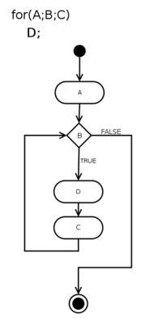
Activity diagram for a for loop
An activity diagram is a diagram that shows activities and actions to describe workflows.^{[1]} In the Unified Modeling Language an activity diagram represents the business and operational step-by-step workflows of components in a system. An activity diagram shows the overall flow of control.

Contents
[hide]
- 1 Overview
- 2 Construction
- 3 See also
- 4 References
- 5 External links

[edit] Overview
In SysML the activity diagram has been extended to indicate flows among steps that convey physical element (e.g., gasoline) or energy (e.g., torque, pressure). Additional changes allow the diagram to better support continuous behaviors and continuous data flows.
In UML 1.x, an activity diagram is a variation of the UML State diagram in which the "states" represent activities, and the transitions represent the completion of those activities.

[edit] Construction
Activity diagrams are typically used for business process modeling. They consist of:
- Initial node.
- Activity final node.
- Activities
The starting point of the diagram is the initial node, and the activity final node is the ending. An activity diagram can have zero or more activity final nodes. In between activities are represented by rounded rectangles.

[edit] See also
- Flowchart
- Control flow graph
- Data flow diagram
- Event-driven process chain
- State diagram
- Pseudocode

[edit] References
- ^ Glossary of Key Terms at McGraw-hill.com. Retrieved 20 July 2008.

[edit] External links
Wikimedia Commons has media related to: Activity diagrams
- UML 2.0 Specification Documents
- Introduction to UML 2 Activity Diagrams
- UML 2 Activity Diagram Guidelines
- UML 2 Activity and Action Models
[hide]
v • d • e
Unified Modeling Language
Actors | Organizations: Object Management Group • UML Partners • Persons: Grady Booch • Ivar Jacobson • James Rumbaugh
Concepts | Object oriented: Object-oriented programming • Object-oriented analysis and design  Structure: Actor • Attribute • Class • Component • Interface • Object • Package  Behavior: Activity • Event • Message • Method • State • Use case  Relationships: Aggregation • Association • Composition • Dependency • Generalization (or Inheritance)  Extensibility: Profile • Stereotype • Other concepts: Multiplicity
Structure diagrams | Class diagram • Component diagram • Composite structure diagram • Deployment diagram • Object diagram • Package diagram
Behavior diagrams | Activity diagram • State Machine diagram • Use case diagram
Interaction diagrams | Communication diagram • Sequence diagram • Interaction overview diagram • Timing diagram
Other topics | Glossary of UML terms • IBM Rational Unified Process • List of UML tools • Systems Modeling Language • UML colors • XMI

Data flow diagram

From Wikipedia, the free encyclopedia
Jump to: navigation, search
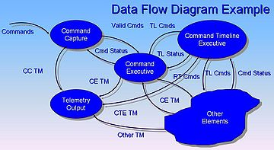
Data Flow Diagram example.^{[1]}
A data flow diagram (DFD) is a graphical representation of the "flow" of data through an information system. It differs from the flowchart as it shows the data flow instead of the control flow of the program.
A data flow diagram can also be used for the visualization of data processing (structured design).

Contents
[hide]
- 1 Overview
- 2 Developing a Data flow diagram
  - 2.1 Top-Down Approach
  - 2.2 Event Partitioning Approach
  - 2.3 Data flow diagram levels
    - 2.3.1 Context Level
    - 2.3.2 Level 0
    - 2.3.3 Level 1
- 3 See also
- 4 References
- 5 Further reading
- 6 External links

[edit] Overview
It is common practice to draw a context-level Data flow diagram first which shows the interaction between the system and outside entities. The DFD is designed to show how a system is divided into smaller portions and to highlight the flow of data between those parts. This context-level Data flow diagram is then "exploded" to show more detail of the system being modeled.
Data flow diagrams were invented by Larry Constantine, the original developer of structured design,^{[2]} based on Martin and Estrin's "data flow graph" model of computation.
Data flow diagrams (DFDs) are one of the three essential perspectives of Structured Systems Analysis and Design Method SSADM. The sponsor of a project and the end users will need to be briefed and consulted throughout all stages of a system's evolution. With a dataflow diagram, users are able to visualize how the system will operate, what the system will accomplish, and how the system will be implemented. The old system's dataflow diagrams can be drawn up and compared with the new system's dataflow diagrams to draw comparisons to implement a more efficient system. Dataflow diagrams can be used to provide the end user with a physical idea of where the data they input ultimately has an effect upon the structure of the whole system from order to dispatch to recook. How any system is developed can be determined through a dataflow diagram.
Developing a Data flow diagram helps in identifying the transaction data in the data model.
There are different notations to draw data flow diagrams, defining different visual representations for processes, datastores, dataflow, and external entities.^{[3]}

[edit] Developing a Data flow diagram
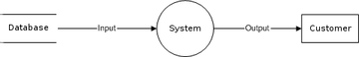
Data flow diagram example
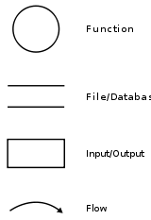
Data flow diagram - Yourdon/DeMarco notation

[edit] Top-Down Approach
- The system designer makes "a context level DFD", which shows the "interaction" (data flows) between "the system" (represented by one process) and "the system environment" (represented by terminators).
- The system is "decomposed in lower level DFD (Zero)" into a set of "processes, data stores, and the data flows between these processes and data stores".
- Each process is then decomposed into an "even lower level diagram containing its subprocesses".
- This approach "then continues on the subsequent subprocesses", until a necessary and sufficient level of detail is reached which is called the primitive process (aka chewable in one bite).

[edit] Event Partitioning Approach
Event partitioning was described by Edward Yourdon in Just Enough Structured Analysis.^{[4]}
- Construct detailed Data flow diagram.
  - The list of all events is made.
  - For each event a process is constructed.
  - Each process is linked (with incoming data flows) directly with other processes or via datastores, so that it has enough information to respond to a given event.
  - The reaction of each process to a given event is modeled by an outgoing data flow.

[edit] Data flow diagram levels

[edit] Context Level
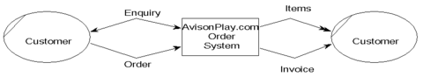
A context level Data flow diagram created using Select SSADM.
This level shows the overall context of the system and its operating environment and shows the whole system as just one process. It does not usually show data stores, unless they are "owned" by external systems, e.g. are accessed by but not maintained by this system, however, these are often shown as external entities.^{[5]}

[edit] Level 0
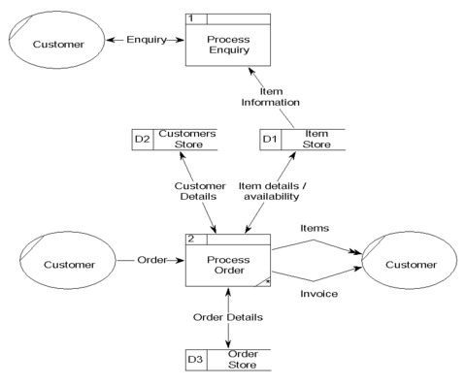
A Level 0 Data flow diagram for the same system.
This level shows all processes at the first level of numbering, data stores, external entities and the data flows between them. The purpose of this level is to show the major high level processes of the system and their interrelation. A process model will have one, and only one, level 0 diagram. A level 0 diagram must be balanced with its parent context level diagram, i.e. there must be the same external entities and the same data flows, these can be broken down to more detail in the level 0, e.g. the "enquiry" data flow could be spilt into "enquiry request" and "enquiry results" and still be valid.^{[5]}

[edit] Level 1
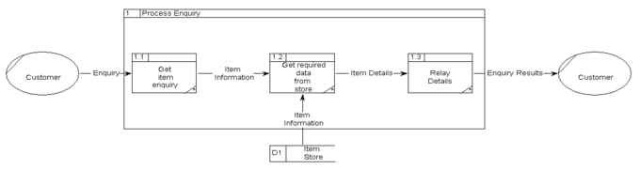
A Level 1 Data flow diagram showing the "Process Enquiry" process for the same system.
This level is a decomposition of a process shown in a level 0 diagram, as such there should be a level 1 diagram for each and every process shown in a level 0 diagram. In this example processes 1.1, 1.2 & 1.3 are all children of process 1, together they wholly and completely describe process 1, and combined must perform the full capacity of this parent process. As before, a level 1 diagram must be balanced with its parent level 0 diagram. ^{[5]}

[edit] See also
- Data island
- Dataflow
- Functional flow block diagram
- Pipeline
- Structure chart

[edit] References
- ^ John Azzolini (2000). Introduction to Systems Engineering Practices. July 2000.
- ^ W. Stevens, G. Myers, L. Constantine, "Structured Design", IBM Systems Journal, 13 (2), 115-139, 1974.
- ^ How to draw Data Flow Diagrams
- ^ Yourdon, Edward. Just Enough Structured Analysis. http://www.yourdon.com/jesa/jesa.php., Chapter 19
- ^ ª ^{b} ^{c} Denis Wixom Roth (2005). Systems Analysis & Design. 3rd Edition. Wiley Higher Education.

[edit] Further reading
- P. D. Bruza and Th. P. van der Weide. "The Semantics of Data Flow Diagrams".

[edit] External links
Wikimedia Commons has media related to: Data flow diagrams
- Case study "Current physical dataflow diagram for Acme Fashion Supplies" ..and accompanying elementary process descriptions
- "Yourdon's chapter on DFDs"
Retrieved from "http://en.wikipedia.org/wiki/Data_flow_diagram"
Categories: Information systems | Data management | Diagrams | Visualization (graphic) | Systems analysis

Views
- Article
- Discussion
- Edit this page
- History

Personal tools
- Log in / create account

Navigation
- Main page
- Contents
- Featured content
- Current events
- Random article

Search
Top of Form
Bottom of Form

Interaction
- About Wikipedia
- Community portal
- Recent changes
- Contact Wikipedia
- Donate to Wikipedia
- Help

Toolbox
- What links here
- Related changes
- Upload file
- Special pages
- Printable version
- Permanent link
- Cite this page

Languages
- Deutsch
- Español
- Français
- Bahasa Indonesia
- Italiano
- עברית
- Nederlands
- 日本語
- Polski
- Português
- Русский
- Slovenčina
- Українська

